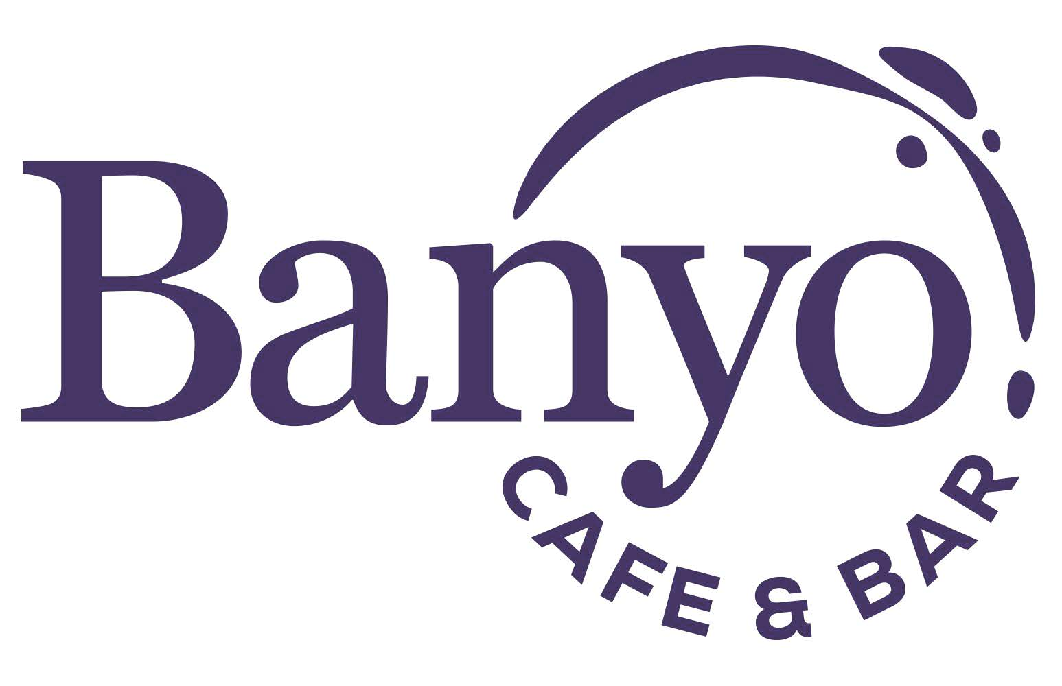
GIFT VOUCHER ORDER FORM
Banyo Cafe and Bar Gift Vouchers available for use at ACU Campus.
Return your completed order form to banyo.cafeandbar@acu.edu.au

Please complete all fields below.

YOUR CONTACT DETAILS (FOR INVOICING PURPOSES)

Date Ordered: | Click here to enter a date. | Date Required: | Click here to enter a date.
Contact Name:
Position: |  | Phone:
Department/School:
Address/Building:
Email:

YOUR ORDER DETAILS

Gift Voucher Selection |  | Quantity |  | Total
$5 Gift Voucher |  |  |  | $
$10 Gift Voucher |  |  |  | $
Total Amount Payable |  |  |  | $

YOUR PAYMENT OPTIONS

Invoice Account #_______________________ PO# _____________________

Direct Deposit Account Details: University of Queensland Union
CBA
BSB: 064 158
Account #: 00050014

A remittance advice must be forwarded by email finance@uqu.com.au

Credit Card Mastercard Visa

Card Number |  | Expiry Date(MM/YY)
Cardholder Name |  | Signature

Please note: All gift vouchers purchased in 2023 will expire on 15 December 2023 .

OFFICE USE ONLY
Received by: |  | Authorised by (Manager):
Signature: |  | Signature:
Date Received: | Click here to enter a date. | Date Approved: | Click here to enter a date.

Issue form to Finance Voucher # ____________________________________________
Finance to email tax invoice (G/L 12780, Dept 150)
Payment Received
Vouchers released. Date: _____________ Invoice # ____________________________________________

